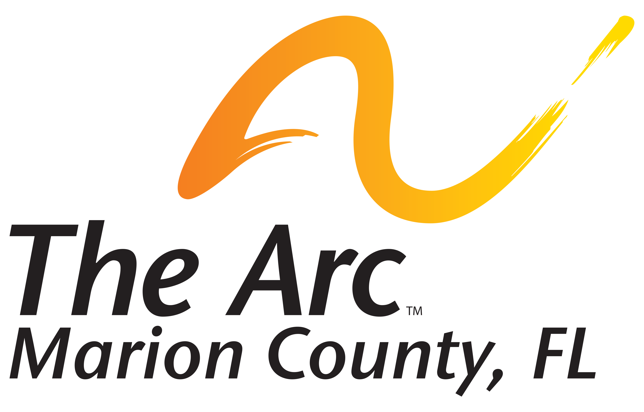

Position Description
Position Title: Executive Director  Department: Entire Agency  Reports To: Board of Directors | FLSA Classification: Exempt  Essential Status: Non-Essential  Job Status: Salaried

The following is a composite representation of the actual position that makes up the classification. It is not intended to cover all possible job requirements. Lines of supervision are as shown on an organization chart.

Position Summary

The Executive Director of The Arc Marion, Inc., with reporting line to the Board of Directors. Responsible for the management of the entire agency, ensures fulfillment of mission and provision of quality services.

Essential Functions

Leadership, Advocacy, Coaching and Strategic Planning
1. Provides oversight of all services and activities of the organization. Provides support, coaching and direction to program directors.
2. Acts as an advocate for the ID/DD population with local, state and federal regulators to secure adequate funding and policies that will support the provision of quality services.
3. Serves on community, regional, and state planning groups/committees, to develop and maintain initiatives to serve and enhance the lives of the ID/DD population.
4. Resolves grievances, conflicts and concerns of consumers, families, staff and other persons affiliated
with the agency.

5. Provides mission-driven, visionary leadership and strategy.
6. Provides inspiring, solution-oriented collaboration that engages the Board of Directors, staff, stakeholders, local community and its leaders.
7 Expands existing partnerships and cultivates new relationships that support The Arc Marion’s vision of Marion County serving as a model community, that embraces persons with disabilities and to help them support their dreams.
8. Establishes and maintains strong working relationships with all governmental agencies necessary for the organization to successfully conduct its programs.

Community Outreach and Fundraising
8. Attends public speaking events and presents information to convey the needs, interests and desires of the ID/DD population.
9. Communicates the organization’s vision, mission and strategy to all stakeholders and generates interest and commitment to The Arc Marion, Inc. programs both internally and externally.
10. Maintains high, positive visibility in the community and cultivates enthusiastic interest in the Board of Director’s and agency activities.
11. Collaborates with Public Relations Committee and serves as the primary spokesperson for the organization with the media and the general public and is the outward face of the agency when dealing with state, local governments and the community.
12. Demonstrates ability to successfully generate new revenue streams, grant writing, cultivating donors, partnerships and sponsors, as well as identifying and creating new and innovative fundraising opportunities.
13. Represents The Arc Marion at meetings, events and other community functions to facilitate community support of organization and consumers.

14. Develops network of contacts with community leaders to facilitate community support and inclusion
opportunities for Consumers.

Organizational Management, Financial Management, Culture and Staff Relations

15. Ensures that organization complies with all laws and regulations pertaining to operations.

16. Oversees the implementation of agency policies and procedures.

17. Oversees all employees.

18. Demonstrates business acumen, financial knowledge, strong analytical abilities as well as excellent communication and people skills.

19. Leads with emotional intelligence, and maintains a culture of service, with an interest in expanding the knowledge, skills and capabilities of clients and staff.

20. Maintains high visibility throughout the organization. Demonstrates and cultivates positive and productive interactions with clients and staff.

21. Provides positive program management, keeping clients first and ensuring the highest quality of services the agency can provide.
22. Demonstrates excellence in management and financial skills with the ability to maintain operational integrity when necessary.
23. Works in efforts with Chief Financial Officer and Finance Committee in developing and monitoring budget for entire organization, overseeing financial management.

24. Reports information and recommendations to Board of Directors and committees of the Board.

25. Completes annual performance evaluations of senior management staff.

26. Demonstrates significant general management experience, including fiscal management, and ensures efficient resource utilization and maintenance to maximize agency resources.

Credentials/Licenses/Employment Requirements

1. Successfully pass Executive level background check including but not limited to Employment/Reference/Education/Credit/Criminal records checks and verifications.

2. Successfully pass a State of Florida, Department of Law Enforcement (FDLE) and local law enforcement checks. Employment is contingent on these findings.

3. Successfully pass company paid physical and drug screening.

4. Subject to alcohol and drug testing as specified in the Drug-free Workplace Policy.

5. Maintain proof of valid driver’s license and a safe driving record.

Education and Experience

1. A minimum of bachelor’s degree from an accredited University with preference given to an advanced
degree in Nonprofit Management, Business Management or Education. Experience may be substituted
for a degree.

2. Five or more years of leadership experience preferably in nonprofit services.

3. Previous experience with individuals with intellectual and/or developmental disabilities preferred.

4.Previous experience in role of Executive Director, Chief Operational Officer, or Vice President.

I have read and understand the job description for the position of Executive Director.

Signature Date

