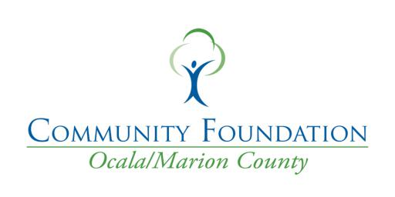

Inspire Gala Nomination Form 2023

Nominee's Company or Organization:

Nominee's Name:

Nominee's Title:

Nominee's Email:

Nominee's Phone Number:

Nominee's Address:

Street Address:
City | State | ZIP / Postal Code

What Individual/Nonprofit/Business is nominating the candidate? Are you a Board Member, Volunteer,

or Donor?

0

Any additional Nonprofit Boards or Committees this nominee may sit on?

Why does this nominee or organization deserve recognition in general for it's work in the community?

Explain how the nominee (or organization) has demonstrated strong leadership, has developed a strong bond to their community, and works with staff or board to create an environment that is fiscally responsible and ethically strong.

How has the nominee or organization delivered positive impact on an important community issue? Please share examples and outcomes.

Nominee's Category

Youth Philanthropist of the Year

Emerging Nonprofit

Nonprofit Board Member of the Year

Nonprofit of the Year

Corporate Partner of the Year

The Unsung Hero

Philanthropist of the Year

Your Name

Your Title

Your Company

Your Email

Your Phone

Please include additional information below on why the nominee fits the category selected for nomination. Remember, this nomination will be read by a committee that is outside of our state. Please be as descriptive as possible. Please see criteria page for additional information.

Nomination Criteria by Category

Youth Philanthropist of The Year-

-Nomination by a teacher, administrator, guidance, coach, or school board member -Student must have completed Adam Hanson Youth Philanthropy in Action program -Student must be within 7th and 12th grade

-Nomination requires an example of an act(s) of philanthropy, volunteer work, and be a role model for other

students
0
Emerging Nonprofit₀-

-Nomination can come from any community member within Marion County

-Nonprofit must be under 5 years old as of Feb 1, 2023

-Nomination requires Nonprofit to have an active board or committee, serving in Marion County, and full example

of how this nonprofit has fulfilled a need to the community

Nonprofit Board Member of The Year-

-Nomination must come from a Nonprofit or fellow board member

-Nominee must have completed 1 year or more with the nominating nonprofit.

-Nomination requires an example of an act(s) of philanthropy, volunteer work, or board commitment to help better the nonprofit and the members it serves

Nonprofit of The Year-

-Nomination can come from anyone in the community that has volunteered, sat on the nonprofit board, received services from the agency, or donated to the nominated nonprofit -Describe the nominee's community efforts, programs, and how they support the community on a daily basis -Describe the nonprofits greatest impact in the community -Nomination requires an example of who the nonprofit serves with in the community

Corporate Partner of The Year-

-Nomination can come from anyone in the community that has witnessed or experienced partnership -Describe the nominee's volunteer efforts. Please include which nonprofit(s) or community programs and initiatives the nominee has volunteered with, which individuals and groups they supported, and length of service. -Describe the impact or value the nominee 's volunteer service has made to the community

-Did the nominee begin a new program, solve a community problem, or initiate creative ways to work with an

organization?

-Describe how the nominee creates a culture of community engagement

0
The Unsung Hero-

-Nomination must come from a Nonprofit, board member, or fellow volunteer -Describe the nominee's volunteer efforts. Please include which nonprofit or community programs and initiatives the nominee has volunteered with, which individuals and groups the supported, and length of service -Describe the impact or value the nominee's volunteer service has made to the community. Be clear and give detailed examples.

Philanthropist of The Year-

-Nomination can come from anyone in the community that has witnessed or experienced the work of the nominee

-The nominee will can be an individual or family

-Describe the nominee's volunteer efforts. Please include which nonprofit(s) or community programs and

initiatives the nominee has volunteered with, which individuals and groups they supported, and length of service.

-Describe the impact and value the philanthropist has brought to our local community through one or more

nonprofit by volunteering, serving on a board, or creating community programs.

0

0
All submissions must be delivered/mailed to 324 SE 24th Street, Ocala, FL 34471 or emailed to Ashley@ocalafoundation.org by Feb 1, 2023. All submissions will be voted on by an out of state

Community Foundation. All nominee names will be blacked out and assigned a number internally by the Community Foundation for Ocala/Marion County. The out of state Community Foundation will review and vote on all categories and send back official results to the Community Foundation for Ocala/Marion County. All nominations will be voted on based on nominations, credentials provided, and qualifications based on category of nomination.

