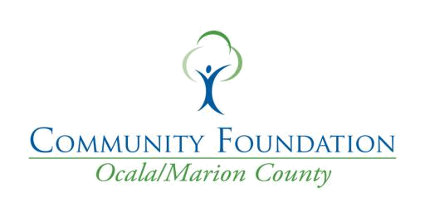

Inspire Gala Nomination Form 2023


Nominee's Company or Organization:

Nominee's Name:

Nominee's Title:

Nominee's Email:

Nominee's Phone Number:

Nominee's Address:

Street Address:
City | State | ZIP / Postal Code



What Nonprofit/Business is nominating the candidate? Are you a Board Member, Volunteer, or Donor? 0

Any additional Nonprofit Boards or Committees this nominee may sit on?

Why does this nominee or organization deserve recognition in general for it's work in the community?


Explain how the nominee (or organization) has demonstrated strong leadership, has developed a strong bond to their community, and works with staff or board to create an environment that is fiscally responsible and ethically strong.

How has the nominee or organization delivered positive impact on an important community issue?


Nominee's Category

Youth Philanthropist of the Year


Emerging Nonprofit

Nonprofit Board Member of the Year

Nonprofit of the Year

Corporate Partner of the Year

The Unsung Hero

Philanthropist of the Year

Your Name

Your Title

Your Company

Your Email

Your Phone
Please include additional information below on why the nominee fits the category selected for nomination. Remember, this nomination will be read by a committee that is outside of our state. Please be as descriptive as possible.


All submissions must be delivered/mailed to 324 SE 24th Street, Ocala, FL 34471 or emailed to Ashley@ocalafoundation.org by Feb 1, 2023. All submissions will be voted on by an out of state

Community Foundation. All nominee names will be blacked out and assigned a number internally by the Community Foundation for Ocala/Marion County. The out of state Community Foundation will review and vote on all categories and send back official results to the Community Foundation for Ocala/Marion County. All nominations will be voted on based on nominations, credentials provided, and qualifications based on category of nomination.

